ECSE-200 Electric Circuits 1 - Quiz #10 (Mar. 29, 2019)

**LAST NAME** ______________________________________________ **MCGILL ID#** __________________

**FIRST NAME­­­­­­­­­**________________________________**SIGNATURE**_________________________________

* ***Only Faculty standard calculator accepted***
* ***No cellphone allowed***
* ***Show all your work***
* ***Clearly indicate your final answer with the SI unit and multiplier***
* ***You have 45 minutes to complete this quiz***

**__________________________________________________________________________________________**

**Question 1:** Consider the circuit shown and assume ideal op-amp behavior. The op-amp circuit is configured as a differentiator where $v_{o}\left(t\right)=-RC\frac{d}{dt}v_{i}\left(t\right)$.

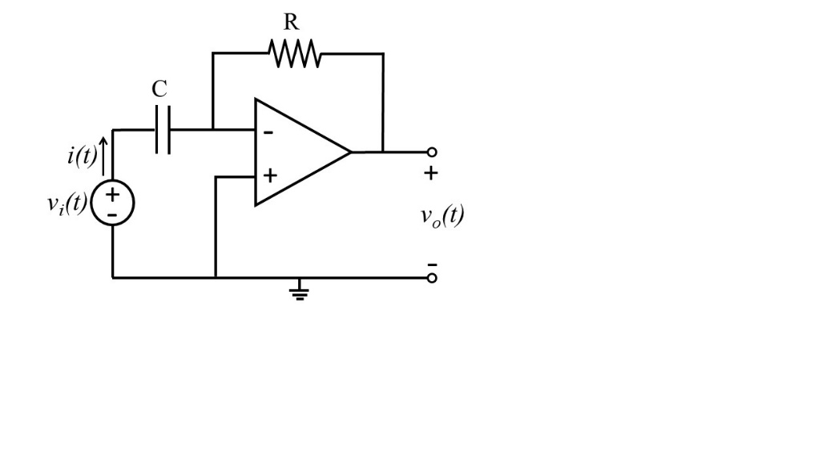

1. Derive the output voltage $v_{o}\left(t\right)$ as a function of the input voltage $v_{i}\left(t\right)$. [1 pt]
2. When the input voltage $v_{i}\left(t\right)$ increases over time at a rate of 0.5 V over 1 milliseconds ($0.5 V/ms$), the current drawn by the input voltage source is 400 μA ($i\left(t\right)=400 μA$) and the output voltage value is $v_{o}\left(t\right)=-5 V.$ What values should *R* and *C* be for this to be possible? [3 pt]
3. Assume now that the resistance of *R* is 10 kΩ (*R* = 10 kΩ) and the capacitance of *C* is 20 nF (*C* = 20 nF). An ac input voltage $v_{i}\left(t\right)=A_{i}\sin\left(ωt\right)$ is applied to the input of the circuit where the amplitude of the input sinusoidal signal is 2 V ($A_{i}=2 V$). The frequency ω is in radians ($ω=2πf$) where the sinusoidal time period *T* is $1/f$. At which frequency $f$ will the amplitude of the output voltage $v_{o}\left(t\right)$ be -2 V? [2 pt]

Extra Working Space

**Question 2:** Consider the circuit shown below. The switch connects the 10 V independent voltage source for *t*<0 s. The circuit reaches steady state before the switch changes its connection to the other voltage source. For *t* > 0 s, the switch connects the 5 V independent voltage source. Answer the following questions.

1. Find the Thévenin equivalent circuit for *t* > 0 s providing the open-circuit voltage ($v_{OC}$) and the Thévenin resistance ($R_{T}$). [2 pt]
2. Connect a 10 μF capacitor across the terminals A and B such that $v\left(t\right)$ is the voltage across the capacitor. Find the values of voltage $v\left(t\right)$ at *t* = 0- s, *t* = 0+ s, and *t* → ∞. In other words, find $v\left(0^{-}\right)$, $v\left(0^{+}\right)$, and $v\left(∞\right)$. [2 pt]
3. Draw the Thévenin equivalent circuit for *t* > 0 s found in part a) connecting the 10 μF capacitor described in part b). As seen in class, the solution to the differential equation obtained from the KVL equation where the variable is $v\left(t\right)$ is $v\left(t\right)=c_{1}+c_{2}e^{-kt}$. Find the value of *k*, *c1*, and *c2*. Recall that $k=\frac{1}{τ}=\frac{1}{R_{T}C}$. [2 pt]
4. Plot $v\left(t\right)$ as a function of time *t*. Clearly indicate the initial and final steady state values as well as the time constant τ. At which time *t* does the voltage change the most, i.e., fastest rate of change? [2 pt]

Extra Working Space